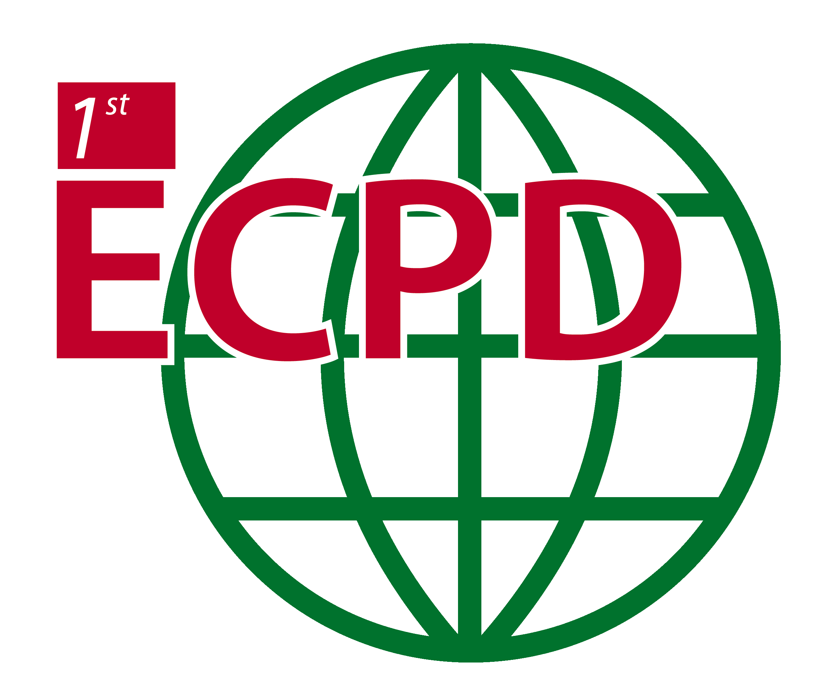 | 1st EPS Conference on Plasma Diagnostics  April 14-17, 2015 - Villa Mondragone, Frascati, Italy  Organized by  ENEA and Tor Vergata University | 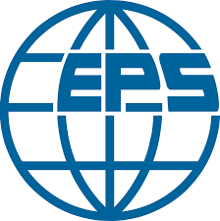

PROGRAMME

Tuesday, April 14th 2015

10.30-14.00 Registration and Welcome drink

14.00-14.30 Conference opening (Tony Donné, A. A. Tuccillo)

Session A1 Chair: Tony Donné
14.30-15.00 “Radar sounding of the auroral plasma”
Cesar La Hoz, (I1.1- Basic and Astrophysical Plasmas)
15.00-15.30 “Combined electron cyclotron emission and heating for the suppression of magnetic islands In fusion plasmas”
Hugo Van den Brand, (I1.2- Magnetic Confinement Fusion)

15.30-16.00 Coffee Break

Session A2 Chair: Tony Donné
16.00-16.20 “Holographic Interferometry in Investigations of the Current Sheet Plasmas”
Anna Frank, (O1.1-Basic and Astrophysical Plasmas)
16.20-16.40 “Microwave Imaging Reflectometry on DIII-D”
Benjamin Tobias, (O1.2 - Magnetic Confinement Fusion)
16.40-17.00 “Recent developments in ultra-high speed and large area photomultiplier tubes”
James Milnes (O1-3, Beam Plasma and Inertial Fusion)
17.00-17.20 “Diagnostics concept development for a future demonstration fusion reactor”
Wolfang Biel (O1.4, Magnetic Confinement Fusion)

END

Wednesday, April 15th 2015

Session B1 Chair: Bob Bingham
8.30-9.15 “X-Ray Diagnostics: from Tokamaks to Applications”
Danilo Pacella (T2.1 – Magnetic Confinement Fusion)
9.15-9.45 “Time correlated single photon counting spectroscopy: principles and applications to single-filament discharges”
Thomas Hoder (I2.1 - Low Temperature and Industrial Plasmas)
9.45-10.15 “Spectro-polarimetrc optical systems for imaging plasma internal fields, structures and flows”
John Howard (I2.2 – Magnetic Confinement Fusion)
10.15-10.45 “VISAR as a fundamental tool to study extreme states of matter”
Michael Koenig (I2.3 - Beam Plasma and Inertial Fusion)

10.45-11.15 Coffee Break (Poster on)

Session B2 Chair: Michael Tatarakis
11.15-11.45 “Single-shot, high-frequency techniques for plasma-induced proton bunch self-modulation measurements”
Roxana Tarkeshian (I2.4 - Beam Plasma and Inertial Fusion)
11.45-12.15 “Correlative Enhanced Scattering in the upper hybrid resonance for study of micro and meso-scale wave phenomena in low-temperature and tokamak plasmas”
Evgeniy Gusakov (I2.5 - Magnetic Confinement Fusion)
12.15-12.45 “Neutron imaging development for inertial confinement fusion experiments”
Olivier Landoas (I2.6 - Beam Plasma and Inertial Fusion)

12.45-14.30 Lunch break

14.30-16.00 Poster session 1 and coffee break

Session B3 Chair: Hong Young Chang
16.00-16.20 “Complex interferometry principles and its potential in case of reference interferograms availability”
Milan Kalal (O2.1 - Basic and Astrophysical Plasmas)
16.20-16.40 “Development and Calibration of Electron Density Measurements in Argon and Helium Plasma Using Laser Collision-Induced Fluorescence”
Ed Barnat (O2.2 - Low Temperature and Industrial Plasmas)
16.40-17.00 “Measurements of strong pulsed magnetic field generated by laser and application to guided electron beam transport”
Mathieu Bailly-Grandvaux (O2.3 - Beam Plasma and Inertial Fusion)
17.00-17.20 “Development of the Cherenkov-type diagnostic system to study runaway electrons within tokamaks”
Marek Rabinski (O2.4 – Magnetic Confinement Fusion)

END

Thurdsday, April 16th 2015

Session C1 Chair: Svetlana Ratynskaia
8.30-9.15 “Diagnostics on complex (dusty) plasmas: a comprehensive survey”
Thomas Hubertus (T3.1 - Low Temperature and Industrial Plasmas)
9.15-9.45 “Fast electron generation for the fast ignitor experiment on LFEX”
Yasunobu Arikawa (I3.1 - Beam Plasma and Inertial Fusion)
9.45-10.15 “Development of a dispersion interferometer for magnetic confinement plasma and its application to atmosphere pressure plasmas”
Tsuyoshi Akiyama (I3.2 – Magnetic Confinement Fusion)
10.15-10.45 “Detecting alfvanic electron acceleration using whistler-mode wave absorption”
Fred Skiff (I3.3 - Basic and Astrophysical Plasmas)

10.45-11.15 Coffee Break (Poster on)

Session C2 Chair: Anna Frank
11.15-11.45 “Imaging Challenges for the ITER Plasma Facing Components Protection”
Jean-Marcel Travere (I3.4 – Magnetic Confinement Fusion)
11.45-12.15 “Microwave diagnostics of plasma filaments produced by a high power femtosecond laser pulse”
Arie Zigler (I3.5 - Beam Plasma and Inertial Fusion)

12.15-14.30 Lunch Break

14.30-16.00 Poster session and Coffee Break

Session C3 Chair: Andrea Murari
16.00-16.20 “Highly resolved dust dynamics in fusion plasmas”
Andrey Shalpegin (O3.1 - Low Temperature and Industrial Plasmas)
16.20-16.40 “Conceptual design of a dust monitor diagnostic for ITER”
Evgeny Veshchev (O3.2 – Magnetic Confinement Fusion)
16.40-17.00 “Overview of the DIXI X-ray framing camera operating at the National Ignition Facility”
Terance Hilsabeck (O3.3 - Beam Plasma and Inertial Fusion)
17.00-17.20 “Advanced Disruption Predictor Based on the Locked Mode Signal: Application to JET”
Jesús Vega (O3.4 – Magnetic Confinement Fusion)
END

*******************************************
20.00-23.30 Social Dinner
*******************************************

Friday, April 17th 2015

Session D1 Chair: Dimitri Batani
8.30-9.15 “Review of recent advances in laser driven ion acceleration and applications”
Markus Roth (T4.1 - Beam Plasma and Inertial Fusion)
9.15-9.45 “Pump-Probe Spectroscopy for Temporal Characterization of Laser-Plasma XUV Pulses”
Shinichi Namba (I4.1 - Basic and Astrophysical Plasmas)
9.45-10.15 “Motional Stark Effect measurements of the local magnetic field in high temperature fusion plasmas”
Robert Wolf (I4.2 – Magnetic Confinement Fusion)
10.15-10.45 “Laser induced flourescence diagnostics of atmospheric pressure plasma jets”
Giorgio Dilecce (I4.3 - Low Temperature and Industrial Plasmas)

10.45-11.15 Coffee Break

Session D2 Chair: Ralph Koenig
11.15-11.45 “Thomson scattering with multi-pass intra-cavity laser system for the study of fast changing structures in fusion plasma”
Mikhail Kantor (I4.4 – Magnetic Confinement Fusion)
11.45-12.15 “Diagnostic systems for the Laser MegaJoule (LMJ)”
Tony Caillaud (I4.65- Beam Plasma and Inertial Fusion)
12.15-12.35 “In situ monitoring of CF2 radicals in dielectric etching plasmas for semiconductor processing using quantum cascade laser absorption spectroscopy”
Norbert Lang (O4.1 - Low Temperature and Industrial Plasmas

12.35-14.20 Lunch Break

Session D3 Chair: Angelo A. Tuccillo
14.20-14.40 “Nitrogen as a spectroscopic tracer for measuring plasma flows in the high-field side SOL of ASDEX Upgrade”
Juuso Karhunen (O4.2 – Magnetic Confinement Fusion)
14.40-15.00 “Investigation Of Effective Sheath Width Measurement Around Cutoff Probe”
Dae Woong Kim (O4.3 - Low Temperature and Industrial Plasmas)
15.00-15.20 “The Set of Diagnostics for the First Operation Campaign of the Wendelstein 7-X Stellarator”
Ralf Koenig (O4.4 – Magnetic Confinement Fusion)
15.20-15.40 “West SXR tomographic system design using gem detector”
Didier Mazon (O4.5 – Magnetic Confinement Fusion)

15:40-16.00 Conference closing

